# Simulator Design Plan

In the design below I have tried to consider the level of difficulty the user may feel with each obstacle/feature in the simulation and group them into zones. This way the user can progress steadily through each of the challenges severity and revisit the safe zone (Starting Lobby) between each of the challenge zones. The numbers reference a description of the feature which is described in further detail in the Zone specifications below.

**Ground Floor Basement Floor**

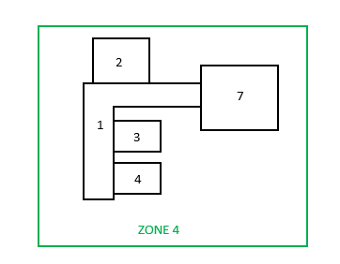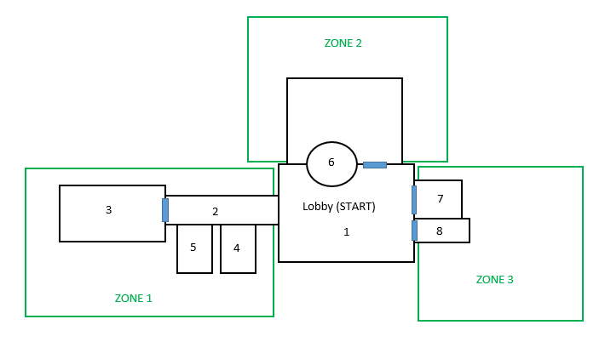

## Zone Specifications

ZONE 1:

As seen in the floor plan Zone 1 consists of 4 structures. There is a narrow hallway (**feature 2**) leading to the bathroom (**feature 3**) and to smaller rooms (**feature 5+6**). The two main features here are the hallway and bathroom where there where talks of single cubicles in the bathroom and windows in the hallway. The small rooms of the hallway (**feature 5+6**) could be small storage cupboards and or just closed doors for effect of enclosure in the hallway. TBC.

ZONE 2:

The main feature here is the revolving door (**feature 6**) which will feature a side door as an alternative. Although I think we should narrow the options for a user and remove the alternative door so that they are steered towards confronting the revolving door. As the main feature of this Zone is the revolving door opening into a large room maybe some suggestions could be made for best utilising the room that will be entered.

ZONE 3:

Zone 3 encompasses an elevator (**feature 7**) and an alternative set of stairs (**feature 8**) leading down to Zone 4. The stairwell and elevator provide an area where a realistic sense of enclosure and restriction can be emulated and therefore we should invest time into the development of this area.

ZONE 4:

The basement level Zone 4 will not bare any windows and feature a narrow hallway (**feature 1**) with a 90% turn so that as the user approaches the turn from a distance it projects the illusion of a dead end. There are 3 rooms leading off of the hallway (**feature 2+3+4**). These could be storage rooms or consist of other triggers for phobia symptoms.

**Other Points:**

As Zone 2 only features the revolving door (**feature 6**) that opens into a single large room maybe the team member who develops this area could also develop starting lobby. The starting lobby, otherwise known as the safe zone should be the most inviting room for the user so lots of light, windows, ceilings etc.